SOAL LATIHAN FISIKA T. TELEKOMUNIKASI – Potensial & Kapasitor
1. A spherical shell with inner radius a and outer radius b is uniformly charged with a charge density ρ.
a) Find the electric field intensity at a distance z from the centre of the shell.
b) Determine also the potential in the distance z.
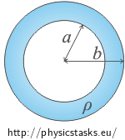
Consider the field inside and outside the shell, i.e. find the behaviour of the electric intensity and the electric potential depending on the variable z in the interval "from zero to infinity".
2. A ball with radius R is unevenly charged with a charge of bulk density proportional to a distance form the centre of the ball: ρ = Kr, where K is a constant.
a) Find the equation describing the electric field intensity at a distance z from the centre of the ball.
b) Determine the electric potential of the ball at a distance z.
Consider a field inside and outside the ball, i.e. find the behaviour of electric intensity and electric potential as a function of distance z from the centre of the ball in the interval "from zero to infinity".
3. A multi-plate capacitor, such as used in radios, consists of four parallel plates arranged one above the other as shown in Figure. The area of each plate is A, and the distance between adjacent plates is d. What is the capacitance of this arrangement ?
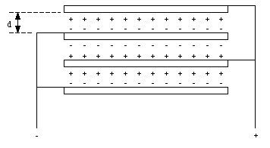
Figure : A Multi-plate Capacitor.
4. 